NETAJI SUBHAS ASHRAM MAHAVIDYALAYA
(Affiliated to S.K.B University)
P.O: SUISA, DIST –PURULIA, PIN .723212
E-mail: nsamprincipal@gmail.com. Webpage: - www.nsamsuisa.org.in
From Principal & secretary Date:-30.09.2021
Ref:-

Online Admission Cancel for the Session 2021-22 Date: up to 03.10.2021

Those who are willing to cancel Admission, please provide Admission details to the following e-mail.
suisacollege@gmail.com
Please attach your Application Form with the mail.

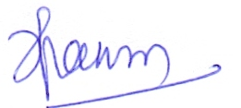
(Dr. Haripriya Panda)
Principal
Netaji Subhas Ashram Mahavidyalaya
